

|  |  |
| --- | --- |
|  | **FPT ACADEMY INTERNATIONAL**  **FPT - APTECH COMPUTER EDUCATION** |

THE FLOWER SHOP



**Supervisor:** Lê Mộng Thuý

**Batch:**  T1.2109.M1

**Group:** 1

**Serial No. Student Name Enrollment Number**

1 Nguyễn Minh Vương Student1339528 Leader

**CONTENT**

**REVIEW 1** **3**

ACKNOWLEDGE **3**

INTRODUCTION 3

PROBLEM DEFINITION 4

FROM THE VIEWPOINT OF VISITORS 4

FROM THE VIEWPOINT OF THE ADMINISTRATOR 4

CUSTOMER'S REQUIREMENTS SPECIFICATIONS (CRS) 4

[CLIENT: THE FLOWER SHOP  
 BUSINESS/PROJECT OBJECTIVE:](#_rnnmazqnjqco) 5

INPUT TO THE SYSTEM: 5

The Flower Shop administrators need to provide: 5

Customers The Flower Shopneed to provide: 5

OUTPUT FROM THE SYSTEM: 5

The Flower Shopadministrators will be able to: 5

The Flower Shopguests will be able to: 5

The Flower Shopcustomer will be able to:: 6

SCOPE OF WORK 6

LOGIN: 6

ORDERING FLOWERS: 6

DATABASE: 6

HARDWARE/ SOFTWARE REQUIREMENTS: 7

HARDWARE 7

SOFTWARE 7

# REVIEW 1

## 

## 1. ACKNOWLEDGEMENT

Our group would like to devote this chapter to express our sincere appreciation to all those who offered us valuable assistance in carrying out this Project.

Firstly, we owe a debt of gratitude to our dedicated instructor, MS. Le Mong Thuy, whose suggestions and encouragement helped us to overcome not only technological challenges but also psychological tension. Without him, our work could not complete successfully.

Secondly, we highly appreciate the Project Team at the Head Office, which has provided us an excellent opportunity to apply what we learned into practice. We are certain that the experiences we gained from this project will facilitate our future career greatly.

Thirdly, we would also like to express my gratitude to all the Admin members of my center for not only providing me with the opportunity to work with them on this project, but also for their support and encouragement throughout the process.

Finally yet importantly, we wish to say a personal thank you to all our dear classmates and team members who are always willing to support us openly and enthusiastically.

## 2. INTRODUCTION

We are in an age when information technology makes buying and selling easier than ever. People can order an expensive phone for an everyday kitchen appliance and everything is done electronically and interacting in real time. Flowers are also not out of this cycle. So we are developing a website called The Flower Shop to provide easy access to buying Flowers online.

The Flower Shop is for an organization who wants to develop an online store where the visitor can be a person who does not have much time to go to the local flower shop or a person who has shopping online habit, or just simply they stay too far from a standalone shop. It will provide its user the following features.

For The Flower Shop’s customer service:

* Unregistered visitor who can register a member account.
* Registered customers can login and manage their account.
* Customers can search for any kind of flower.
* Customers can see the flower's introduction before buying.
* Customers can buy flowers after adding them to the shopping cart.
* Customers can view cart history.
* Customers can review order history and make changes.
* Customers can check out.

## 3. PROBLEM DEFINITION

After analyzing the project specifications of The Flower Shop, to fulfill customer’s requirements properly, we came to conclusion that in order to achieve the best result, we should deal with following queries:

### FROM THE VIEW POINT OF VISITORS

* A homepage will show the main products, suitable logo, and display the logo on all the pages in the site.
* A navigation header and footer that will include all the functions implemented in the website.
* Visitors can search flowers, view summary, regist,...
* Registered customers can buy flowers, add flowers to cart, view cart and check out.
* Registered customers can login and logout to their profile, view order history.

### FROM THE VIEWPOINT OF THE ADMINISTRATOR

* A login page will grant access to The Flower Shop Admin.
* Admin can view, add, update, delete and manage Customers.
* Admin can view, add, update, delete and manage Flowers.
* Admin can view, update, delete, customer accounts.
* Admin can view, update and manage orders.

## 

## 4. CUSTOMER'S REQUIREMENTS SPECIFICATIONS (CRS)

### CLIENT: THE FLOWER SHOP BUSINESS/PROJECT OBJECTIVE:

The project is to design an online website for advertising and selling all types of flowers.

### 

### INPUT TO THE SYSTEM:

#### The Flower Shop Administrators need to provide:

* Information required in order to create an account to access the admin system.

#### The Flower Shop Customers need to provide:

* Personal information to buy products.
* Information required in order to create an account to access the customer system.

### OUTPUT FROM THE SYSTEM:

#### The Flower Shop Administrators will be able to:

* Login/Logout to the admin system.
* List of products.
* List of customer accounts

#### Visitors will be able to:

* List of products.
* View products that they have chosen.

#### The Flower Shop Customers will be able to:

* List of products.
* View products that they have chosen.
* View profile
* View cart.
* View order history.

### 

### SCOPE OF WORK

* The application should perform the following functions:

#### LOGIN:

* There are 2 types of accounts in the application: “Administrator” will login as “Admin”. “Viewer” will login as “Customer”
* For “Admin”:
  + Can view the customer id, name, update, delete, lock, unlock.
  + Can view, add, update, delete and manage Flowers.
  + Can view, add, update, delete and manage Ship.
  + Can view and manage order.
* For “Customer” :
  + Can visit website The Flower Shop to purchase flowers, add flowers to cart, check out.
  + Can search any flowers.
  + Can view cart history.
  + Can review order history and make change.

#### ORDERING FLOWERS:

* When the customer chooses a flowers and the selected flowers will be added to the cart.
* Customers can buy flowers at shopping cart after pressing the “Checkout” button and fill the information.

#### DATABASE:

* The information about products, customers, orders will be stored in the database.

#### HARDWARE/ SOFTWARE REQUIREMENTS:

##### HARDWARE

Web Server

|  |  |
| --- | --- |
| **Processor** | Intel Core I7 or higher. |
| **Memory** | 32 GB RAM or greater. |
| **Modem/ADSL** | Internet access is required. |

Client

|  |  |
| --- | --- |
| **Processor** | Intel Core I5 or higher. |
| **Memory** | 8 GB RAM or greater. |
| **Monitor** | Super VGA (1024x768) or higher resolution. |
| **Modem/ADSL** | Internet access is required. |

##### SOFTWARE

Web Server

|  |  |
| --- | --- |
| **Operation System** | Window 7 or later. |
| **Browser** | Google Chrome version 35. |
| **Database** | MySQL |
| **Software** | Internet Information Service |
| PHP - Laravel framework |

Client

|  |  |
| --- | --- |
| **Operation System** | Window 7 or higher. |
| **Browser** | Google Chrome version 35. |

**DEVELOPMENT SOFTWARE**

* Microsoft Windows 10.
* MySQL.
* Visual Studio Code.
* Google Chrome.
* XAMPP.

**TECHNOLOGY**

* PHP - Laravel framework.
* JQuery.
* Javascript.
* HTML/CSS/Bootstrap.

| **Project: The Flower Shop** | | **Date of preparation of activity plan:** | | | |
| --- | --- | --- | --- | --- | --- |
| **#** | **Task** | **Start date** | **Days** | **Tteam member name** | **Status** |
| 1 | Acknowledgement | 25/6/2022 | 1 | All Members | completed |
| 2 | Introduction | 25/6/2022 | 1 | All Members | completed |
| 3 | Problem definition | 25/6/2022 | 1 | All Members | completed |
| 4 | Customer requirement specification (CSR) | 25/6/2022 | 1 | All Members | completed |
| 5 | Scope of work | 25/6/2022 | 1 | All Members | completed |
| 6 | Hardware/software requirement | 25/6/2022 | 1 | All Members | completed |
| 7 | Task Sheet | 25/6/2022 | 1 | All Members | completed |
| Date: 25/6/2022 | | | | | |
| Signature of instructor | | Signature of Team Leader | | | |
|  | |  | | | |
| Ms. LÊ MỘNG THUÝ | | Nguyễn Minh Vương | | | |

# REVIEW 2

# 1. USECASE

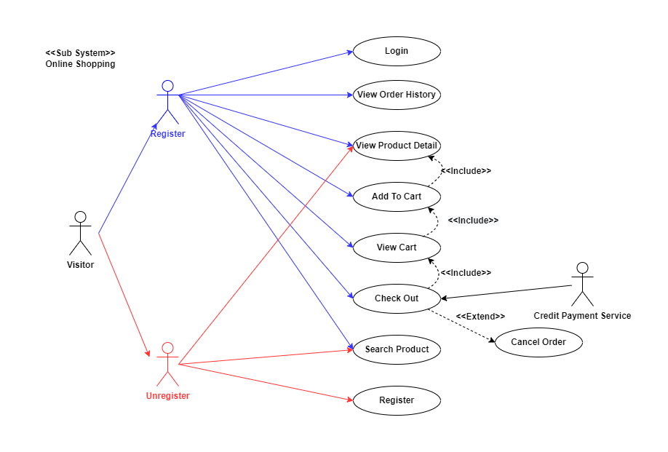

## CUSTOMER

#### LOGIN AS CUSTOMER

|  |  |  |
| --- | --- | --- |
| **Use case name** | Login | |
| **Actors** | Customer | |
| **Description** | Customer who has registered an account can login | |
| **Requirements** | Customer provides username and password | |
| **Pre-conditions** | Visitor must register an account | |
| **Post-conditions** | Success: Visitor is logged in to website | |
| Fail: Refill information | |
| **Basic flow** | **Actor’s actions:** | **System’s responses:** |
| 1. Visitor click ‘Login’ button on Home Page  3. Actor inputs Email and Password, then click the ‘Login’ button | 2. System redirects to Login Page with the following controls:  - “Email” text field  - “Password” text field  - “Login” button  4. System checks the information  5. System redirects to Customer’s dashboard |
| **Exceptions** | **Actor’s actions:** | **System’s responses:** |
| 1. Actor inputs invalid email and password. | System redirects to Login page with the following controls:  - “Email” text field  - “Password” text field  - “Login” button  System shows message:  “invalid email and password” |

#### 

#### REGISTER AS CUSTOMER:

|  |  |  |
| --- | --- | --- |
| **Use case name** | Register as Visitor | |
| **Actors** | Customer | |
| **Description** | Customer who has registered an account can login | |
| **Requirements** | Customer registers an account on the website and becomes a member | |
| **Pre-conditions** | Customer provides their register information | |
| **Post-conditions** | Success: Visitor creates a User account in this website | |
| Fail: Refill information | |
| **Basic flow** | **Actor’s actions:** | **System’s responses:** |
| 1. Visitor click ‘Register’ button on Home Page  3. Visitor inputs register’s information and click “Register” button | 2. System redirects to Register Page and display Registration form with the following controls:  - “Username” text field  - “Password” text field  - “Confirm Password” text field  - “Email” text field  - “Phone” text field  - “Register” button  - “Reset” button  - “Phone” button  4. System validates the information  5. System inserts the account into database  6. System show success message |
| **Exceptions** | **Actor’s actions:** | **System’s responses:** |
| - Actor left “Username” text field blank. | System displays message to customer: - “Username cannot be blank”. |
|  | - Username has already existed. | - “This Username has already existed”. |
|  | - Actor left “Password” text field blank. | - “Password cannot be blank”. |
|  | - Password has not matched regular expression condition (at least 1 uppercase, 1 lowercase, 1 number, 1 special character, and no space character | - “Password must have at least 1 uppercase, 1 lowercase, 1 number, 1 special character, and no space character” |
|  | - Actor left “Confirm Password” text field blank. | - “Confirm Password cannot be blank”. |
|  | - Password and confirm password don’t match. | - “Confirm Password does not match password.”. |
|  | - Actor left “Email” text field blank. | - “Email cannot be blank”. |
|  | - Email has already existed. | - “This Email has already existed”. |
|  | - Actor input invalid email format | - “Email has invalid format” |
|  | - Actor left “Phone” text field blank. | - “Phone cannot be blank”. |
|  | - Input phone is not numeric format or phone length is not between 8 and 14 characters. | - “The phone number should be numeric only and must be between 8 and 14 digits”. |

#### 

#### 

#### 

#### 

#### 

#### 

#### 

## PRODUCT

#### SEARCH PRODUCTS:

|  |  |  |
| --- | --- | --- |
| **Use case name** | Search Product | |
| **Actors** | Registered Customer/ New Customer | |
| **Description** | Customer can search product | |
| **Requirements** | Customer provides search phrase | |
| **Pre-conditions** | N/A | |
| **Post-conditions** | Success: Show product that matches search phrase | |
| Fail: No product is shown | |
| **Basic flow** | **Actor’s actions:** | **System’s responses:** |
| 1. Actor inputs search phrase  2.Actor clicks product’s name in list or view every product that matches search phrase | System shows list of products that match the search phrase |
| **Exceptions** | **Actor’s actions:** | **System’s responses:** |
| Actor enter is not wrong product | The system does not show the search product |

#### 

#### 

#### 

#### VIEW PRODUCT DETAIL:

|  |  |  |
| --- | --- | --- |
| **Use case name** | View Product Detail | |
| **Actors** | Registered Customer/ New Customer | |
| **Description** | Customer can view product detail | |
| **Requirements** | Customer select product to show product’s detail | |
| **Pre-conditions** | N/A | |
| **Post-conditions** | Success: Display product detail matching the selected product | |
| Fail: No product is shown | |
| **Basic flow** | **Actor’s actions:** | **System’s responses:** |
| Actor select product | System shows product’s detail matching selected product |
| **Exceptions** | **Actor’s actions:** | **System’s responses:** |
| Actor no select product | The system does not show the select product |

#### 

#### 

#### 

#### 

#### 

#### CREATE CART (ADD TO CART)::

|  |  |  |
| --- | --- | --- |
| **Use case name** | Create Cart (Add To Cart) | |
| **Actors** | Registered Customer | |
| **Description** | Customer can add product to their cart | |
| **Requirements** | Customer must choose at least one product | |
| **Pre-conditions** | Customer must log in before adding product | |
| **Post-conditions** | Success: Actor add product to cart successfully | |
| Fail: Redirects to Login Pages | |
| **Basic flow** | **Actor’s actions:** | **System’s responses:** |
| Actor chooses a product and click “Add to cart” | System adds selected product to cart by id of this product |
| **Exceptions** | **Actor’s actions:** | **System’s responses:** |
| Actor inputs more products than there are in stock | System shows messages error |

#### 

#### 

#### 

#### 

#### 

#### 

#### VIEW CART

|  |  |  |
| --- | --- | --- |
| **Use case name** | View Cart | |
| **Actors** | Registered can view their cart | |
| **Description** | Customer can view their cart | |
| **Requirements** | N/A | |
| **Pre-conditions** | Customer must log in before view cart | |
| **Post-conditions** | Success: Customer can view their cart | |
| Fail: Redirects to Login Pages | |
| **Basic flow** | **Actor’s actions:** | **System’s responses:** |
| Actor click on “Cart” icon. | System shows cart and added products |
| **Exceptions** | **Actor’s actions:** | **System’s responses:** |
| 1. Actor clicks “x”– Close button- on table  2. Actor change quantity of a product  3. Actor clicks “x” – close button – in the right side of each product. | 1. System redirects to current page.  2. System update quantity of this product into cart.  3. System removes this product from cart |

#### 

#### 

#### 

#### 

#### CHECKOUT

|  |  |  |
| --- | --- | --- |
| **Use case name** | Check Out | |
| **Actors** | Check out and Place order | |
| **Description** | Customer can order products | |
| **Requirements** | Customer must has at least 1 product in cart | |
| **Pre-conditions** | Customer must log in before adding product | |
| **Post-conditions** | Success: Order successfully | |
| Fail: Redirects to Login Pages | |
| **Basic flow** | **Actor’s actions:** | **System’s responses:** |
| 1. Actor click “Add to cart” button or “Cart” icon  2. Actor inputs order information then click “Place Order” button  3. Actor clicks “Check out with” button.  4. Actor inputs Card owner’s name, card number and security code if actor choose payment by credit card  5. Actor views order’s status in Order page | 1. System shows cart and added products  2. System shows all products in cart with calculated total price and show following controls:  - “Customer name” text field.  - “Phone” text field.  - “Address” text field.  - “Province” select box.  - “Delivery time frame” select box.  - “Payment” table.  3. Systems shows Payment tab type according to type of payment actors choose  4. System validates information  5.. System redirects to Order page and show order’s status |
| **Alternative flow** | **Actor’s actions:** | **System’s responses:** |
| 1. Actor clicks “x”– Close button- on table  2. Actor clicks “X” button on each product  3. Actors clicks “Home” button. | 1. System redirects to cart page.  2. System removes product from cart.  3. System redirect to Home pages. |
| **Exceptions** | **Actor’s actions:** | **System’s responses:** |
| 1. Actor inputs more products than there are in stock.  2. Actor left “Billing name” text field blank.  3. Actor left “Address” text field blank  4. Actor left “Delivery date” blank.  5. Actor left “Delivery time frame” blank  6. Actor left “Payment” dropdown blank.  7. Actor inputs invalid card information | The system will report the corresponding error:  1. “Product out of stock”.  2. “Order name must not be blank”.  3. “Address must not be blank”.  4. “Must choose a delivery date”.  5. “Must choose a delivery time frame”  6. “Must choose a payment method”  7.“Invalid card”. |

#### 

#### 

#### 

#### 

#### 

#### 

#### VIEW ORDER HISTORY

|  |  |  |
| --- | --- | --- |
| **Use case name** | View Order History | |
| **Actors** | Registered Customer | |
| **Description** | Customer can view their order history | |
| **Requirements** | N/A | |
| **Pre-conditions** | Customer must log in to website | |
| **Post-conditions** | Success: Customer can view their order. | |
| Fail: Customer cannot see their order. | |
| **Basic flow** | **Actor’s actions:** | **System’s responses:** |
| 1. Actor chooses “Login” icon on Menu  2. Actor chooses “Purchase history” on sides bar  3. Actor selects the order that they want to view in “Purchase history” and clicks “View” Button. | 1. System redirects to Login page  2. System redirects to “Purchase history” page and displays a list of existing orders and their status  3. System validates inputs by id of Order and displays all order’s detail and its status |
| **Exceptions** | **Actor’s actions:** | **System’s responses:** |
| 1. Actor no select product  2. Actors clicks “Home” button | 1. The system does not show the select product  2. System redirect to Home pages |

#### 

#### CANCEL ORDER

|  |  |  |
| --- | --- | --- |
| **Use case name** | Cancel Order | |
| **Actors** | Registered Customer | |
| **Description** | Customer can cancel their order | |
| **Requirements** | Customer provides order’s id to cancel | |
| **Pre-conditions** | Customer must log in to website and only can cancel when this order has not been confirmed by admin | |
| **Post-conditions** | Success: Cancel successfully. | |
| Fail: Order cannot cancel. | |
| **Basic flow** | **Actor’s actions:** | **System’s responses:** |
| 1. Actor chooses “Login” icon on Menu  2. Actor chooses “Purchase history” on sides bar  3.. Actor selects the order that they want to cancel in “Purchase history”  4. Clicks “Cancel” Button. | 1. System redirects to Login page  2. System redirects to “Purchase history” page and displays a list of existing orders and their status  3. System validates inputs by id of order  4. System change order status in database and system displays message |
| **Exceptions** | **Actor’s actions:** | **System’s responses:** |
| 1. Actors clicks “Home” button | 1. System redirect to Home pages |

## ADMIN

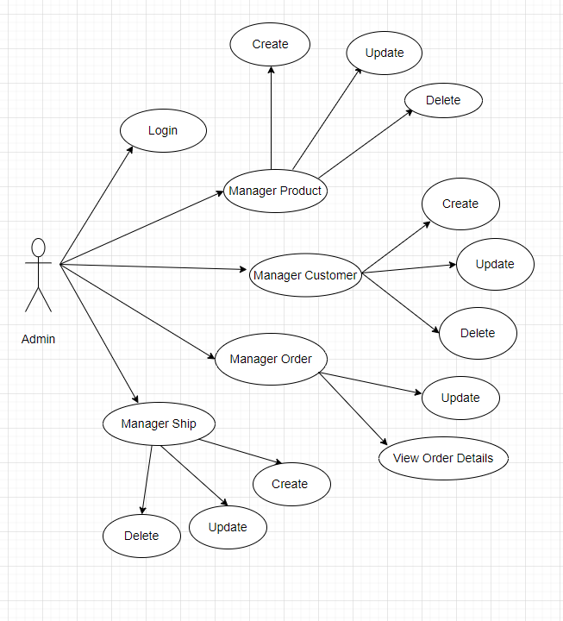

## 

**LOGIN**

|  |  |  |
| --- | --- | --- |
| **Use case name** | Login | |
| **Actor** | **Admin** | |
| **Description** | When Admin wants to manage products, views orders and orders detail | |
| **Requirements** | Admin provides username and password | |
| **Pre-conditions** | Admin must be exist on database | |
| **Post-conditions** | Success: Admin is logged in to Admin website. | |
| Fail: refill information | |
| **Basic flow** | **Actor’s actions:** | **System’s responses:** |
| 1. Actor clicks on ‘Login’ button.  3. Actor inputs Email and Password, then click the ‘Login’ button. | 2. System redirects to Login Page with the following controls:  - 'Email' text field   - 'Password' text field  - 'Login' button  4. System validates the information.  5. System redirects to Admin website |
| **Exceptions** | **Actor’s actions:** | **System’s responses:** |
| 1. Actor inputs invalid email and password | System redirects to Login page with the following controls:  - ‘Email’ text field  - ‘Password’ text field  - ‘Login’ button. |

**PRODUCTS**

**CREATE NEW PRODUCT**

|  |  |  |
| --- | --- | --- |
| **Use case name** | Create new product | |
| **Actor** | **Admin** | |
| **Description** | When Admin wants to create a new product | |
| **Requirements** | Actor provides product’s information | |
| **Pre-conditions** | Actor is logged in Admin | |
| **Post-conditions** | Success: new product is added into the database | |
| Fail: refill information | |
| **Basic flow** | **Actor’s actions:** | **System’s responses:** |
| 1. Actor chooses Product Tab on menu. 3. Actor clicks ‘Add New Product’ button.  5. Actor inputs information to create new product | 2. System redirects to ‘Product’ page and display a list of existing product.  4. System displays a form with the following fields:  - id  - name  - description  - price  - quantity  - active  - detail  - image  6. System validates inputs.  7. System adds product into database.  8. System displays confirmation message or error message. |

**UPDATE PRODUCT**

|  |  |  |
| --- | --- | --- |
| **Use case name** | Update product’s detail | |
| **Actor** | **Admin** | |
| **Description** | When actor wants to update product | |
| **Requirements** | Actor provides product’s information | |
| **Pre-conditions** | Actor is logged in Admin | |
| **Post-conditions** | Success: product is updated in database | |
| Fail: refill information | |
| **Basic flow** | **Actor’s actions:** | **System’s responses:** |
| 1. Actor chooses Product Tab on menu. 3. Actor clicks ‘View Details’ button on a product.  5. Actor chooses the criteria they want to update and input information. | 2. System redirects to ‘Product’ page and display a list of existing product.  4. System displays a form with the following fields:  - id  - name  - description  - price  - quantity  - active  - detail  - image  6. System validates inputs.  7. System update product into database.  8. System displays confirmation message or error message.  9. System redirects to product’s detail page. |

**DELETE PRODUCT**

|  |  |  |
| --- | --- | --- |
| **Use case name** | Delete product | |
| **Actor** | **Admin** | |
| **Description** | When actor wants to delete product from the database | |
| **Requirements** | Actor provides product’s information | |
| **Pre-conditions** | Actor is logged in Admin | |
| **Post-conditions** | Success: product is deleted in database | |
| Fail: product is not delete from the database | |
| **Basic flow** | **Actor’s actions:** | **System’s responses:** |
| 1. Actor chooses Product Tab on menu.  3. Actor clicks ‘Delete’ button. | 2. System redirects to ‘Product’ page and display a list of existing product.  4. System delete product in the database.  5. System displays confirmation or error. |

**ORDER**

**VIEW ORDER**

|  |  |  |
| --- | --- | --- |
| **Use case name** | View Order | |
| **Actor** | **Admin** | |
| **Description** | When Admin wants to know the order of the product. | |
| **Requirements** | Admin has at least 1 order on website. | |
| **Pre-conditions** | Actor is logged in Admin | |
| **Post-conditions** | Success: product is shown in the website | |
| Fail: Page View Order cannot see from the website | |
| **Basic flow** | **Actor’s actions:** | **System’s responses:** |
| 1. Actor chooses View Order on menu.  3. Actor clicks ‘View’ button. | 2. System redirects to ‘Order List’ page and display a list of Order.  4. System show Order in the website.  5. System displays confirmation or error. |

**VIEW ORDER DETAIL**

|  |  |  |
| --- | --- | --- |
| **Use case name** | View Order Detail | |
| **Actor** | **Admin** | |
| **Description** | When Admin wants to see View Order Detail from the website. | |
| **Requirements** | Admin has at least 1 order on website. | |
| **Pre-conditions** | Actor is logged in Admin | |
| **Post-conditions** | Success: Admin can view Order Detail on the website. | |
| Fail: Admin cant’ view the Order Detail on the website. | |
| **Basic flow** | **Actor’s actions:** | **System’s responses:** |
| 1. Actor chooses View Order on menu.  3. Actor clicks ‘Detail’ button. | 2. System redirects to ‘Order List’ page and display a list of Order.  4. System show Order Details in the website  5. System displays confirmation or error. |

# 

# 2. DATA FLOW DIAGRAM (DFD)

LEVEL 0

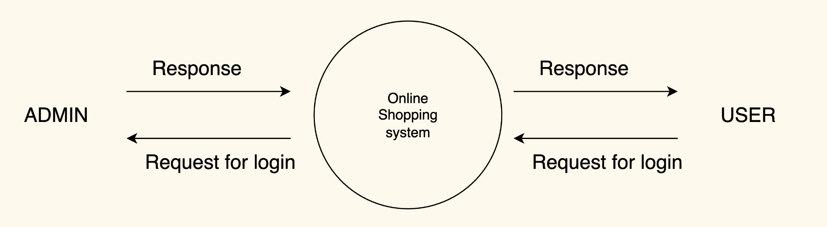



### ADMINSIDE LEVEL 1

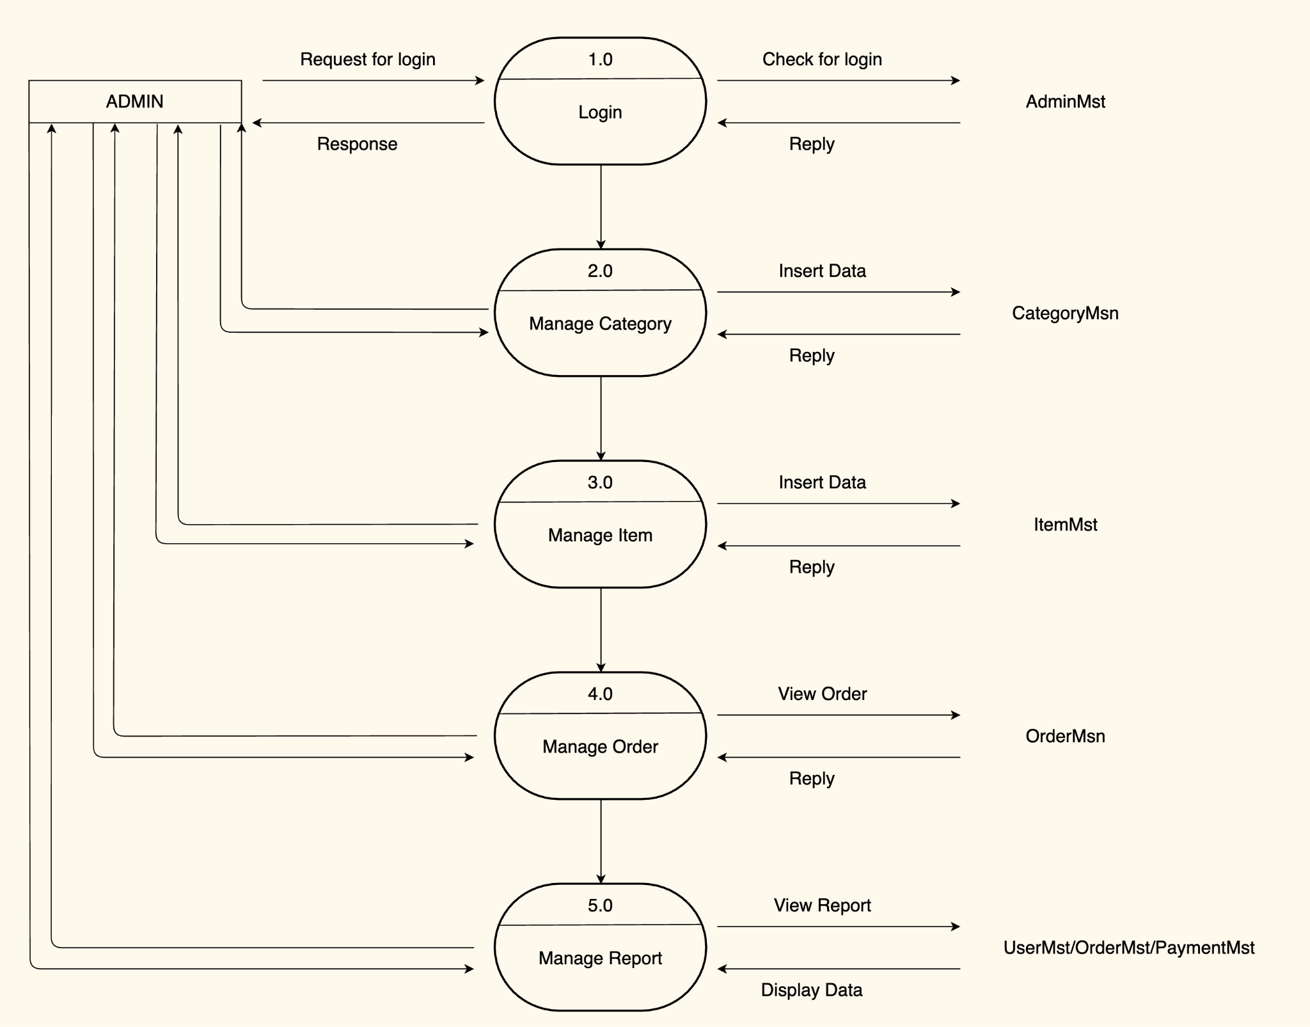



### ADMINSIDE LEVEL 2

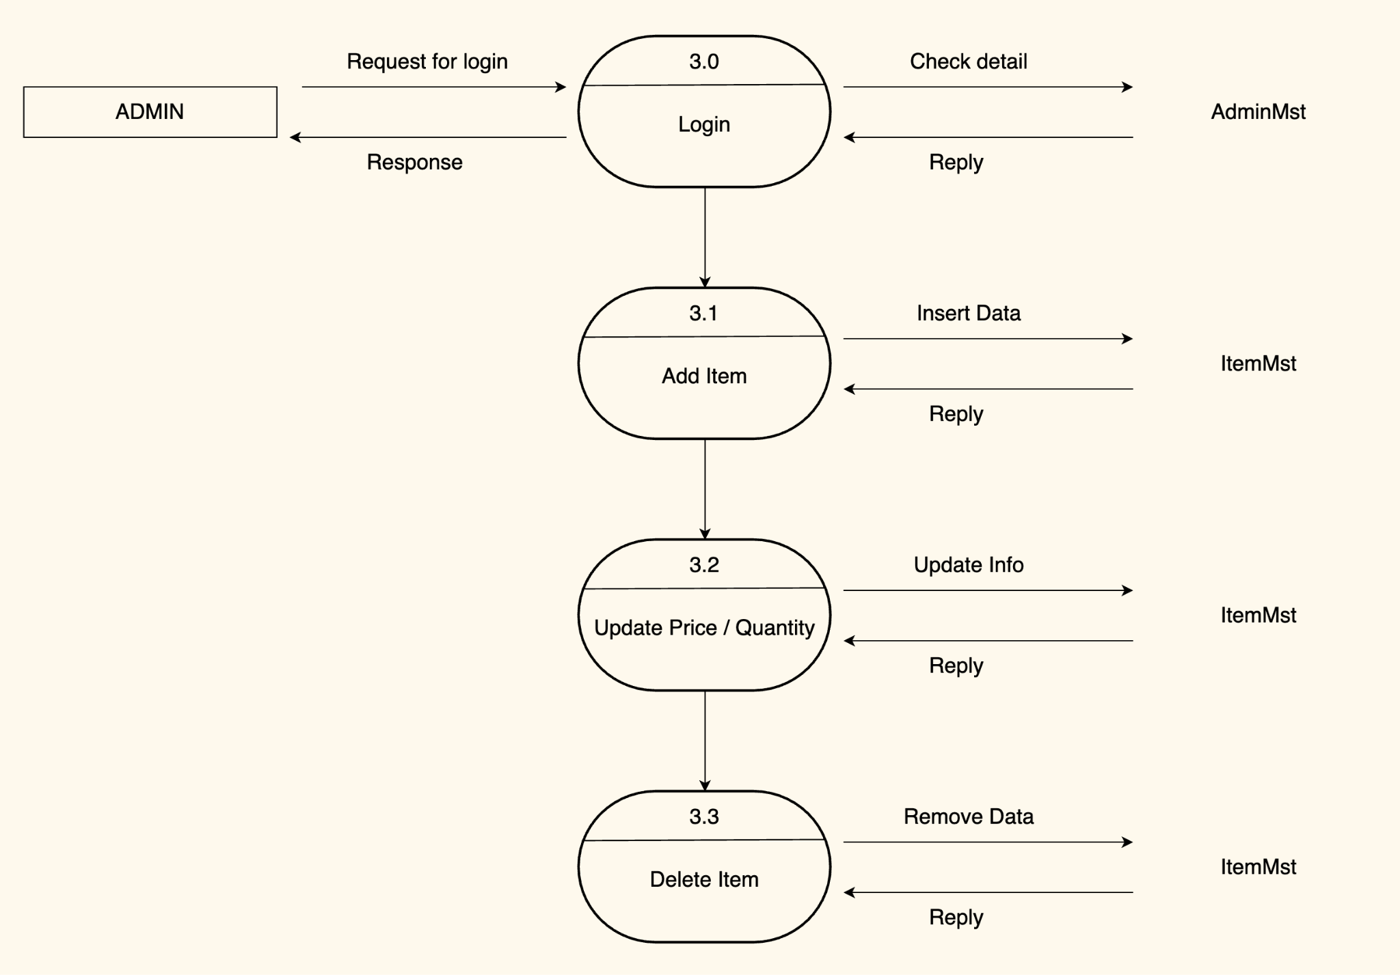

### ADMINSIDE LEVEL 3

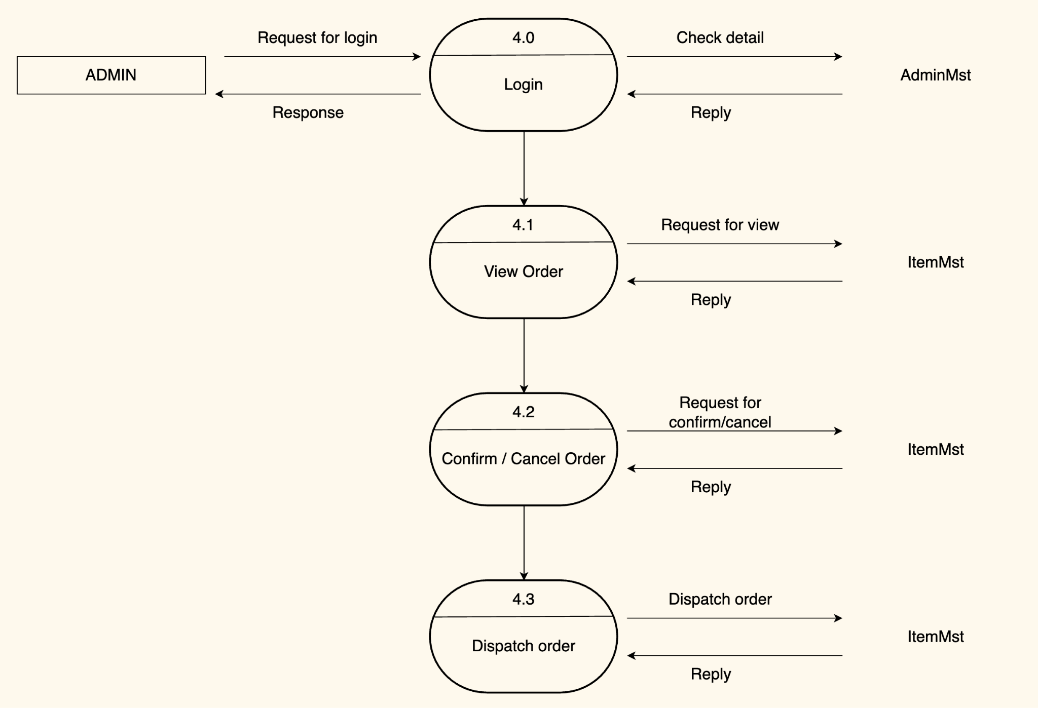

### ADMINSIDE LEVEL 4

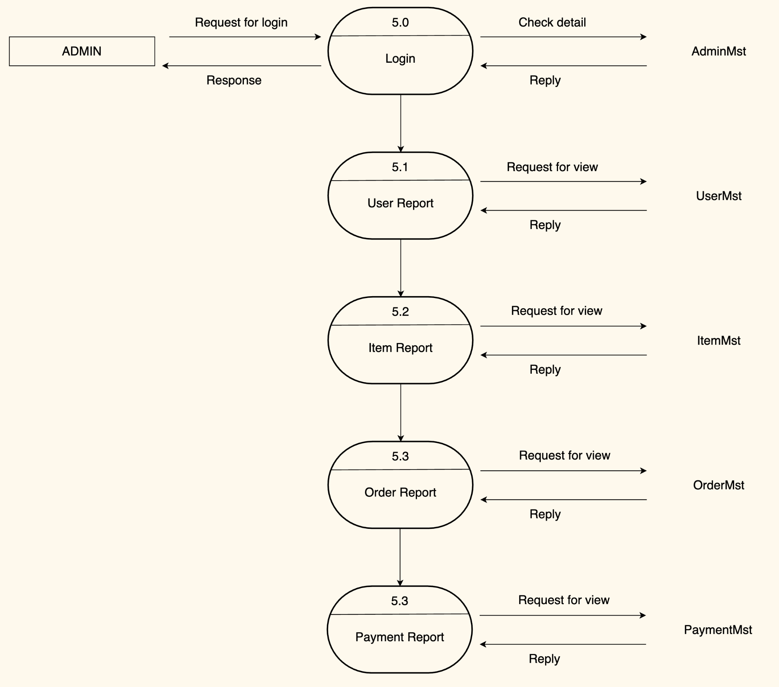



### CUSTOMERSIDE LEVEL 1











### CUSTOMERSIDE LEVEL 2

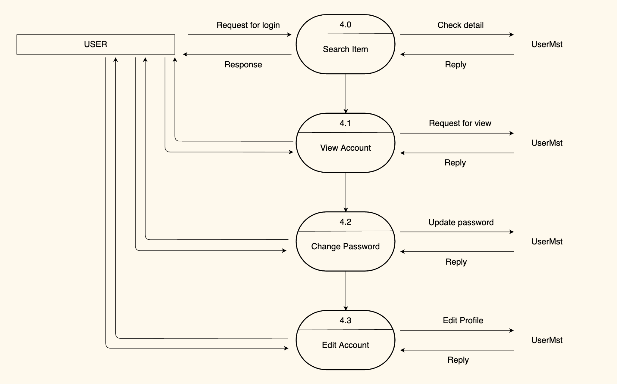









### CUSTOMERSIDE LEVEL 3

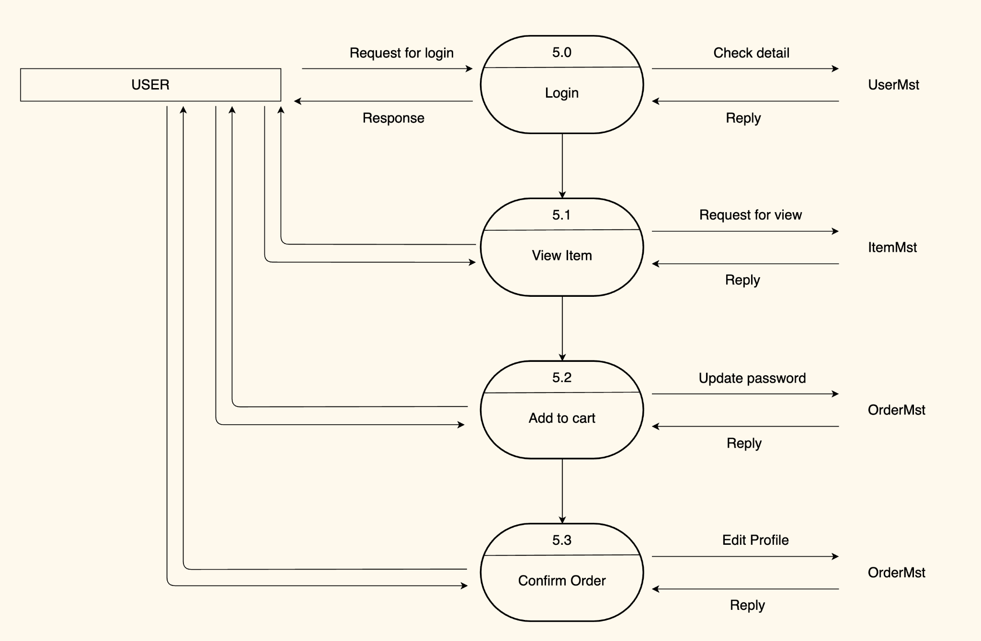



## 

## 

## 

## 

# 3. ENTITY PROPERTIES

### Order

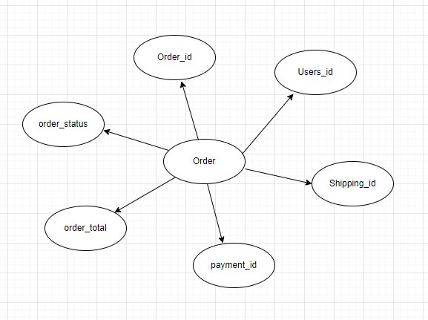

### Order Detaisl

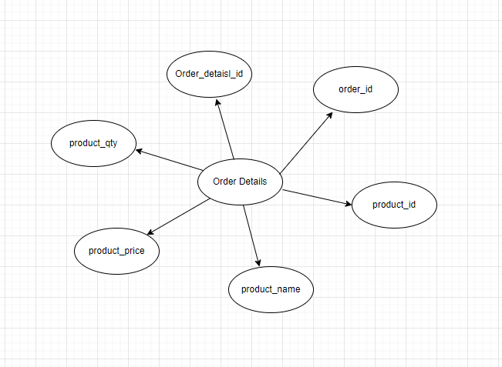

### Category

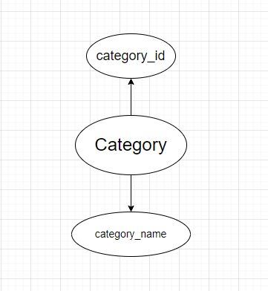

### Customer

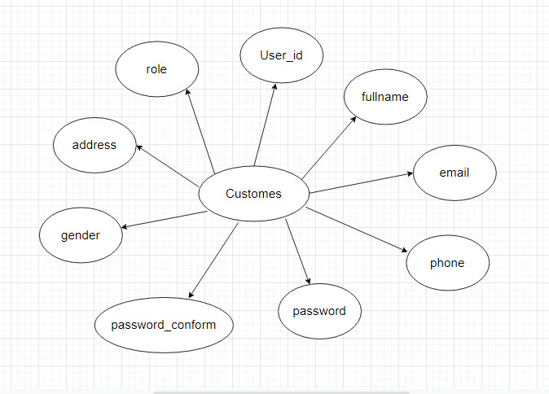

### 

### Admin

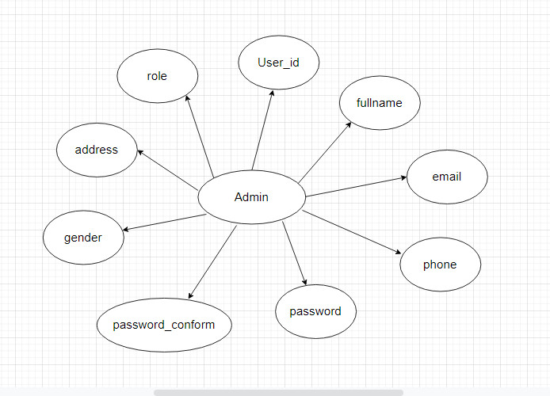

### Product

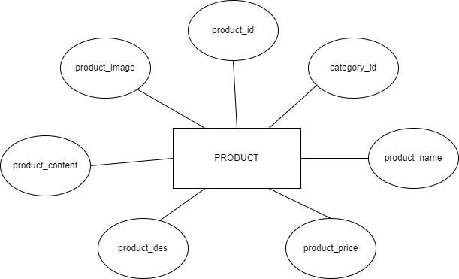

### Password Reset

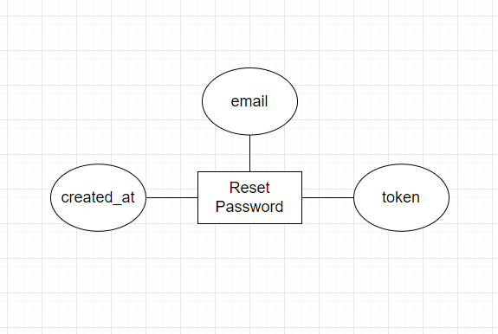

### 

### 

### 

### 

### 

### View_product



### Shipping

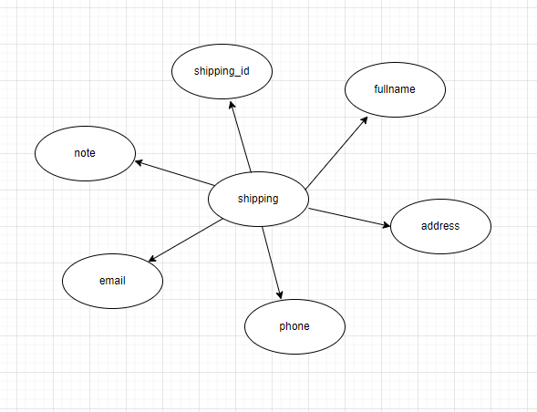

### Payment

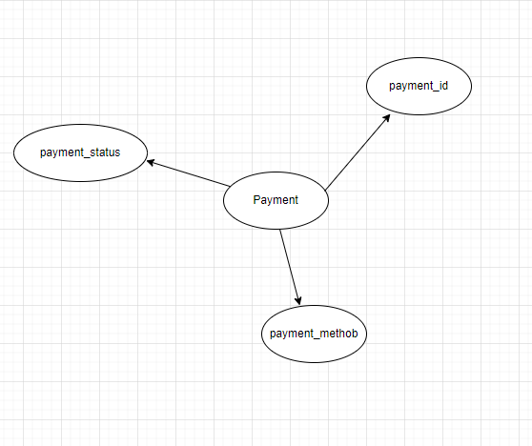

### City

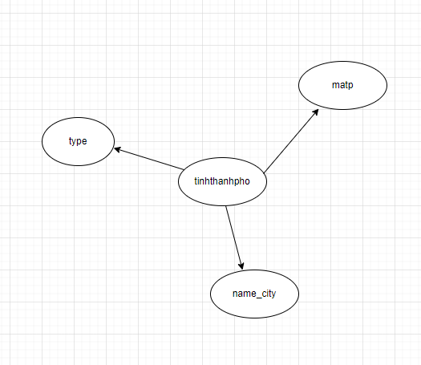

### Province

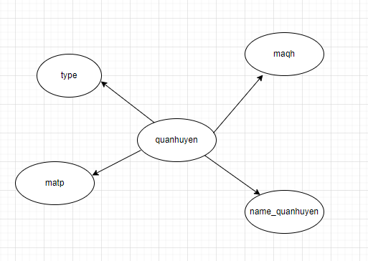

### Wards

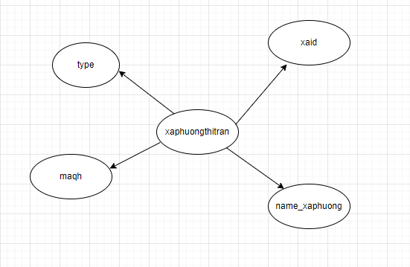

# 4. ENTITY RELATIONSHIP DIAGRAM (ERD)

### LOGICAL ERD

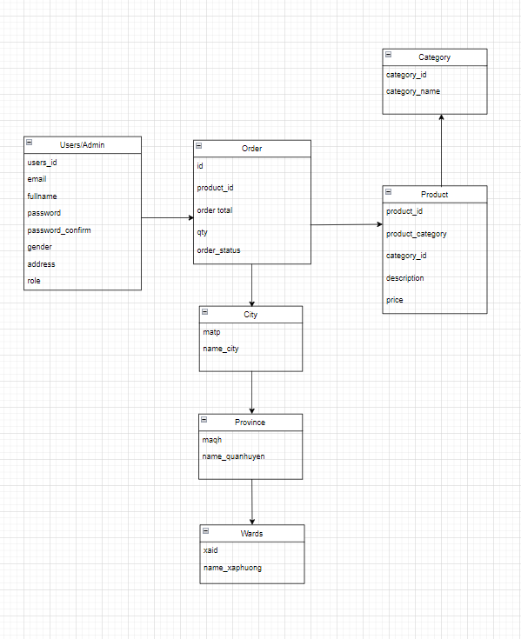

# 

# 5. TABLE DESIGN

#### TABLE STRUCTURE FOR TABLE CATEGORY

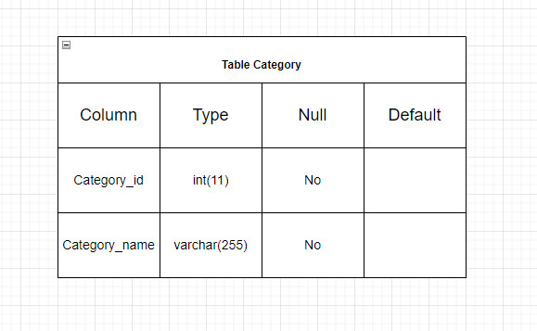

#### TABLE STRUCTURE FOR TABLE PRODUCT

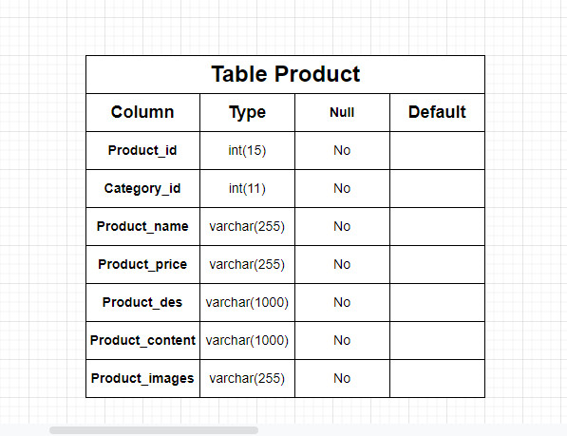

#### TABLE STRUCTURE FOR TABLE ORDER

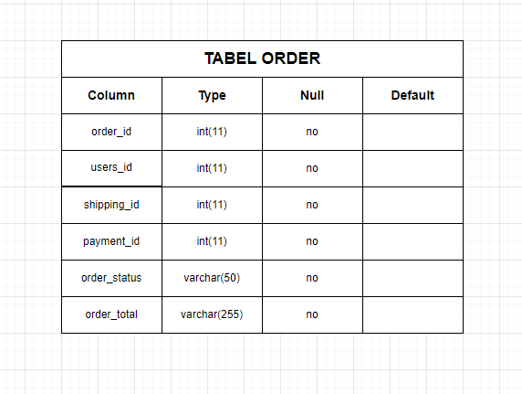

#### TABLE STRUCTURE FOR TABLE ORDER_DETAILS

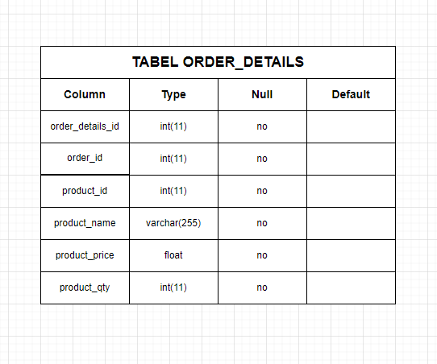

#### TABLE STRUCTURE FOR TABLE PASSWORD_RESETS

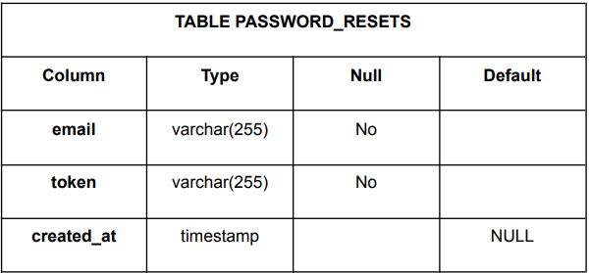

#### TABLE STRUCTURE FOR TABLE CUSTOMER

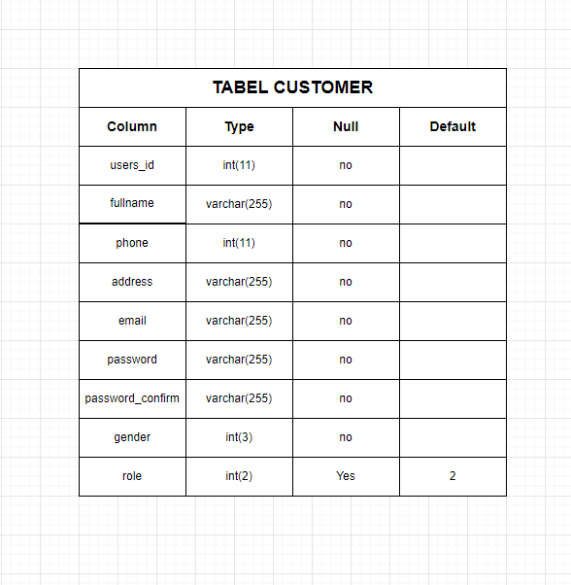

#### TABLE STRUCTURE FOR TABLE ADMIN

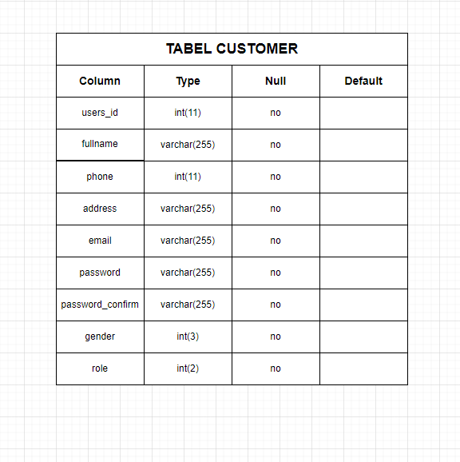

#### TABLE STRUCTURE FOR SHIPPING

#### 

# 6. TASK SHEET REVIEW 2

|  |  |  |  |  |  |  |
| --- | --- | --- | --- | --- | --- | --- |
| Project: The Flower Shop | | Activity Plan Prepared By | Date of Preparation of Activity Plan: | | | |
| Sr./No. | Task | Actual Start Date | Actual Days | Team member name | Status |
| 1 | Use Case | Vương | 07-July-22 | 3 | All members | Completed |
| 2 | Data Flow Diagram (DFD) | 09-July-22 | 3 | All members | Completed |
| 3 | Entity Relationship Diagram (ERD) | 11-July-22 | 3 | All members | Completed |
| 4 | Entity Properties | 13-July-22 | 3 | All members | Completed |
| 5 | Table Design | 15-July-22 | 3 | All members | Completed |
| Signature of Instructor:  Ms. Le Mong Thuy | | | Signature of Team Leader:  Nguyễn Minh Vương | | | |

REVIEW 3

# SITE MAP

## HOME SITE MAP

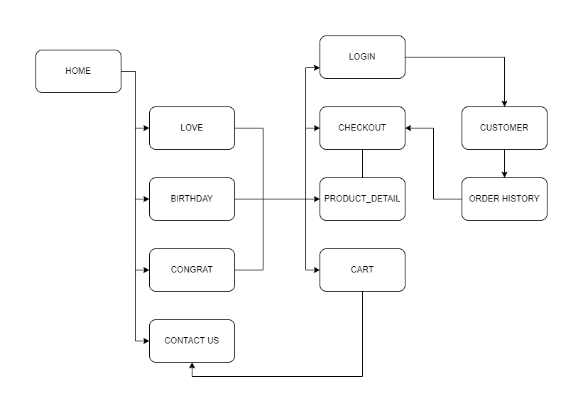

## ADMIN’S SITE MAP

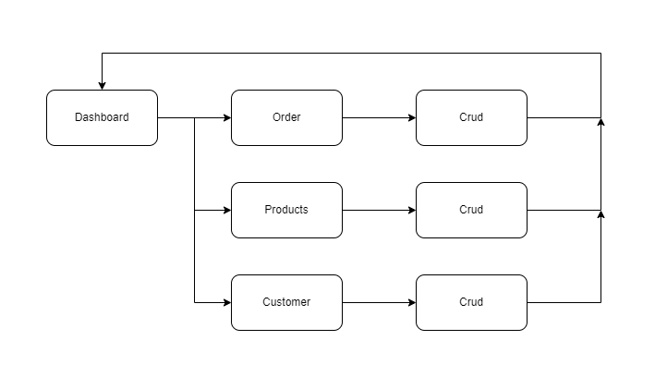

# THE FLOWER SHOP WIREFRAME

## HOME PAGE

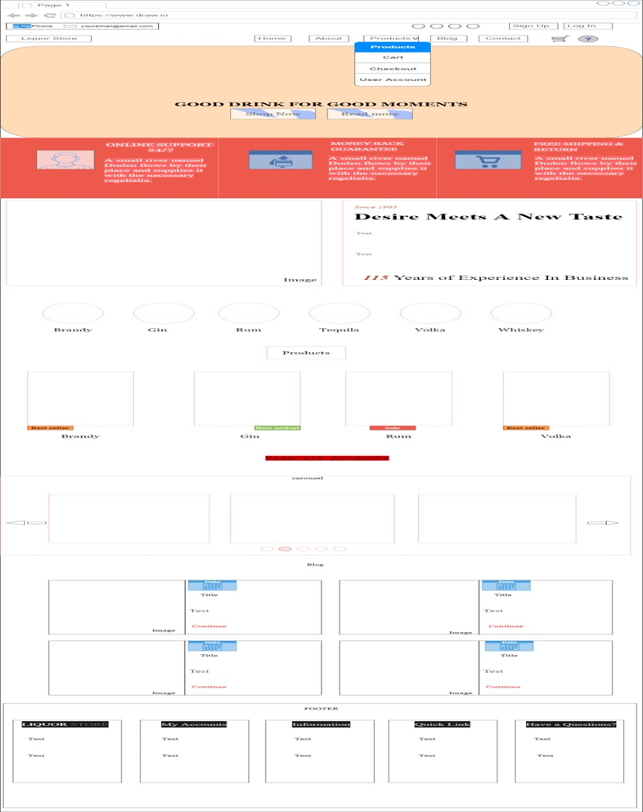

## ADMIN

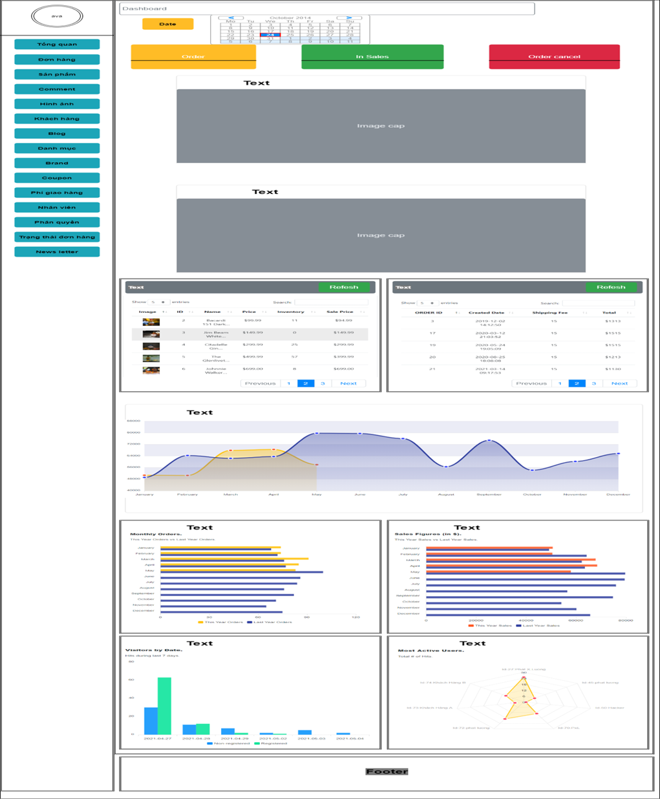

## PRODUCT

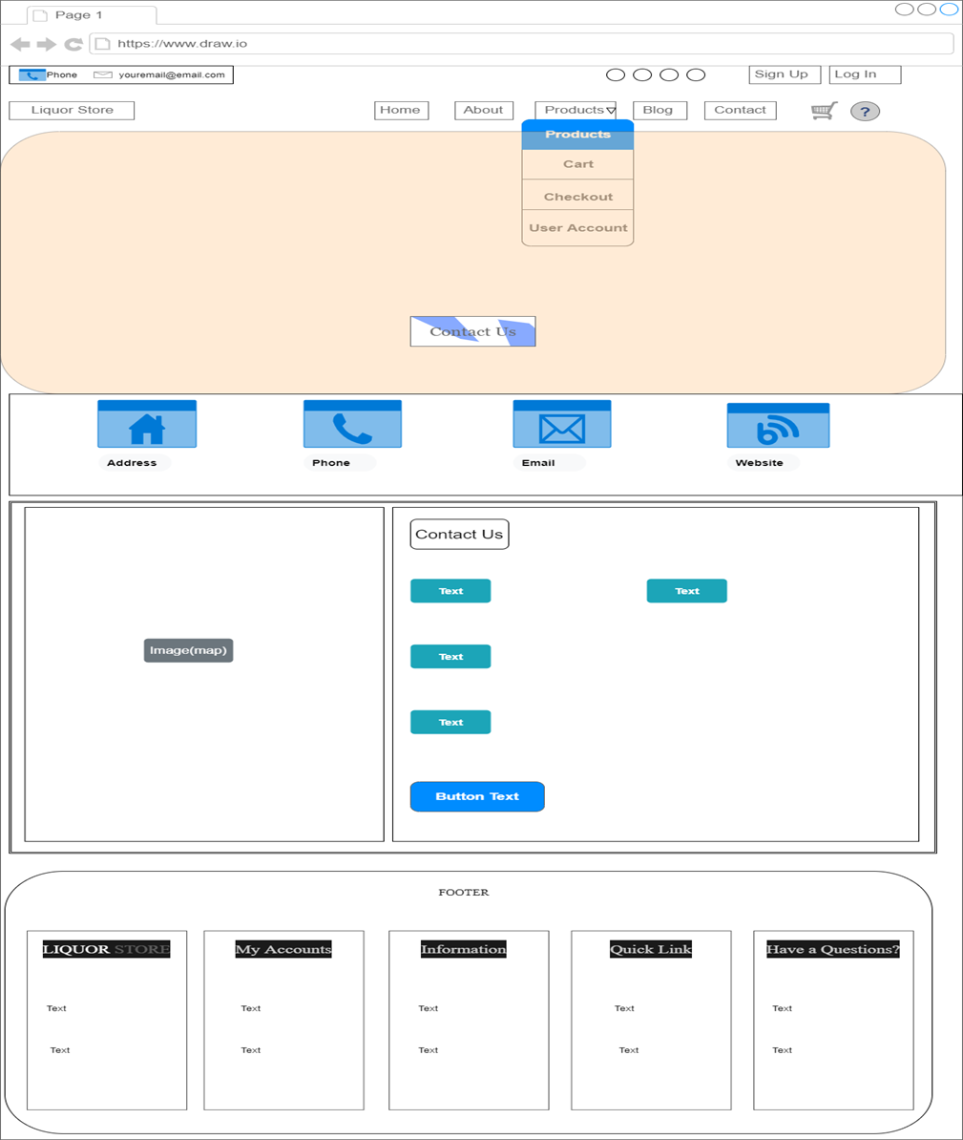

## PRODUCT DETAIL

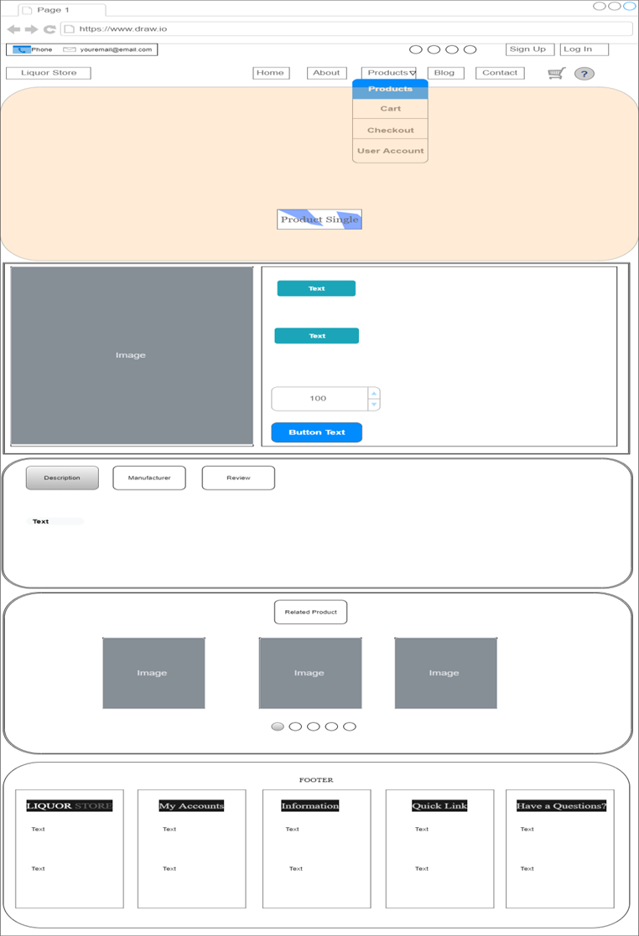

## USER ACCOUNT PROFILE

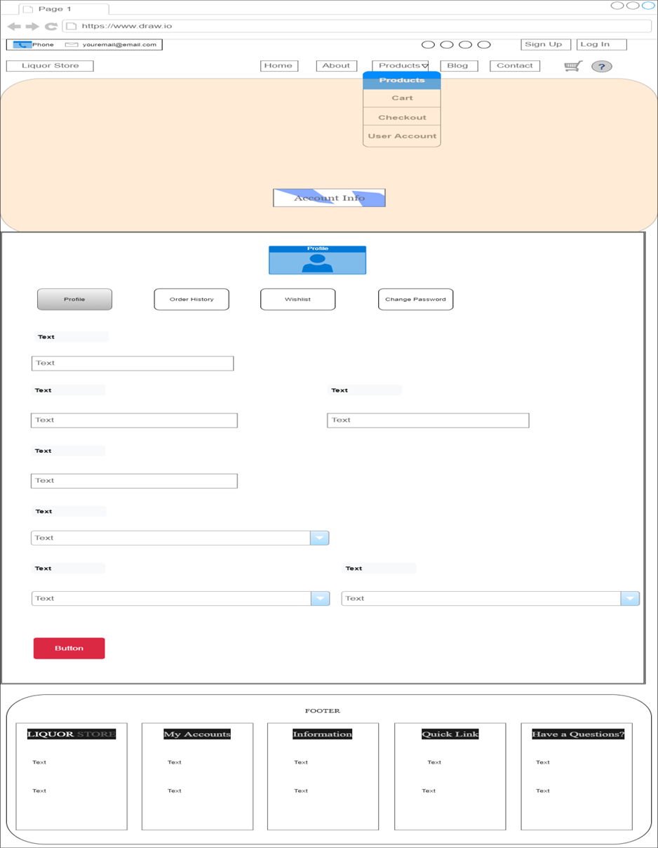

## USER ACCOUNT ORDER HISTORY

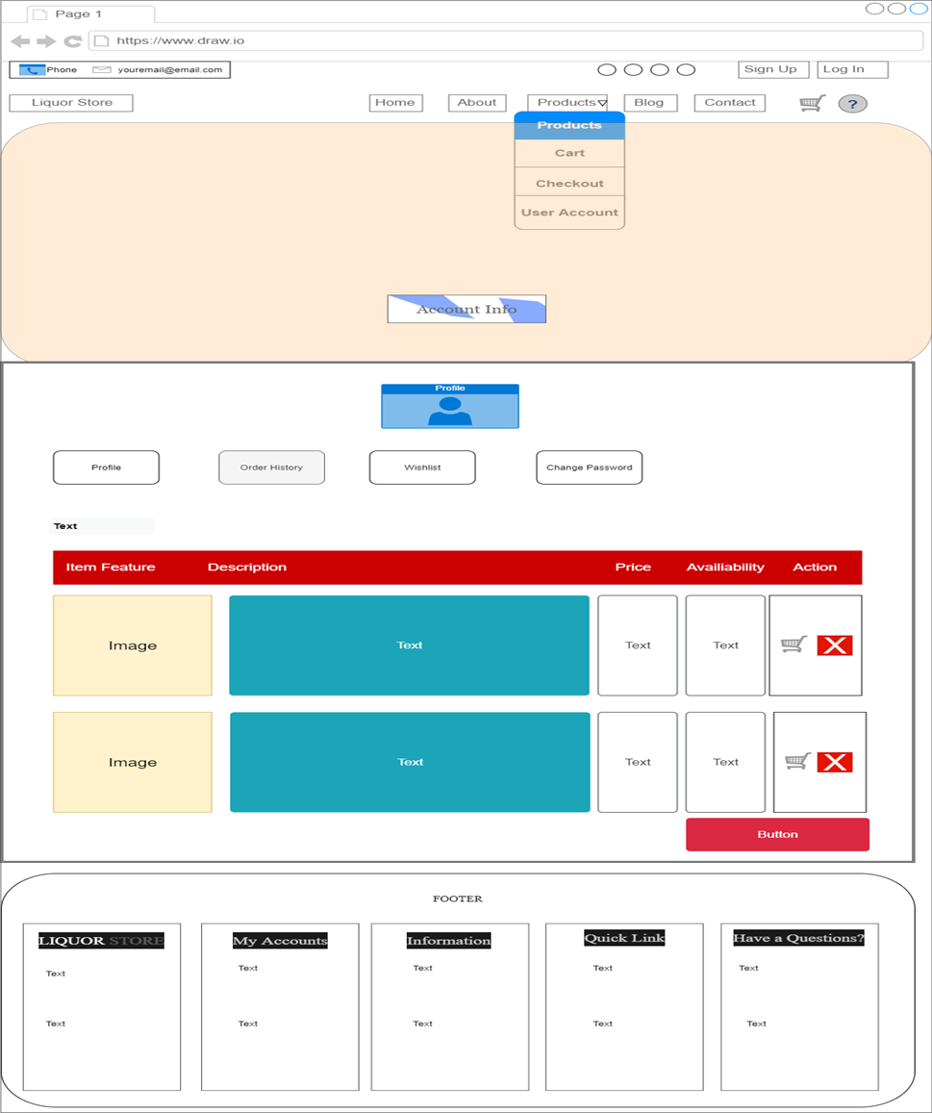

## USER ACCOUNT WISHLIST

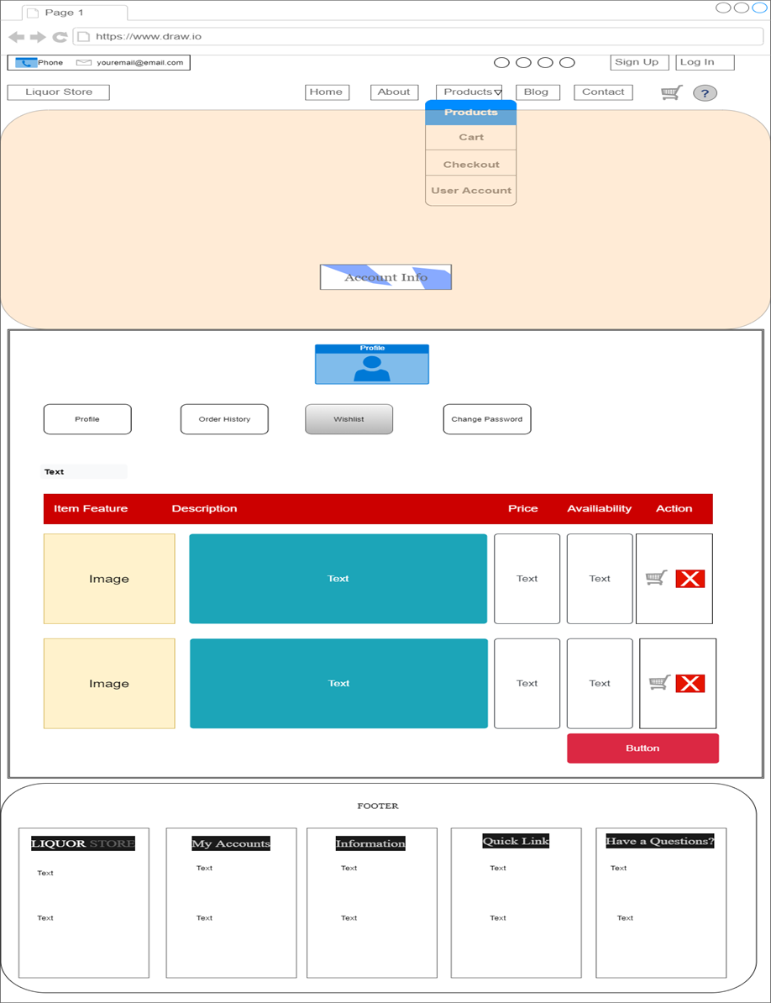

## USER ACCOUNT CHANGE PASSWORD

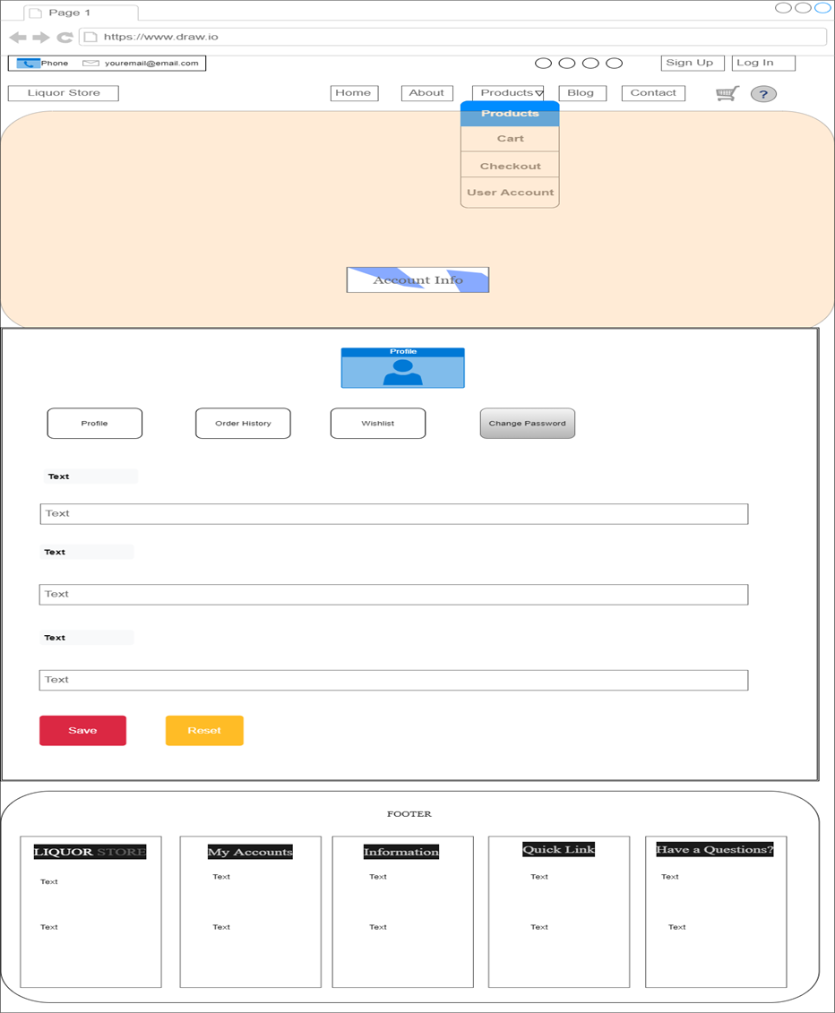

1. **THE FLOWER SHOP SCREENSHOT**

**Home Pages**

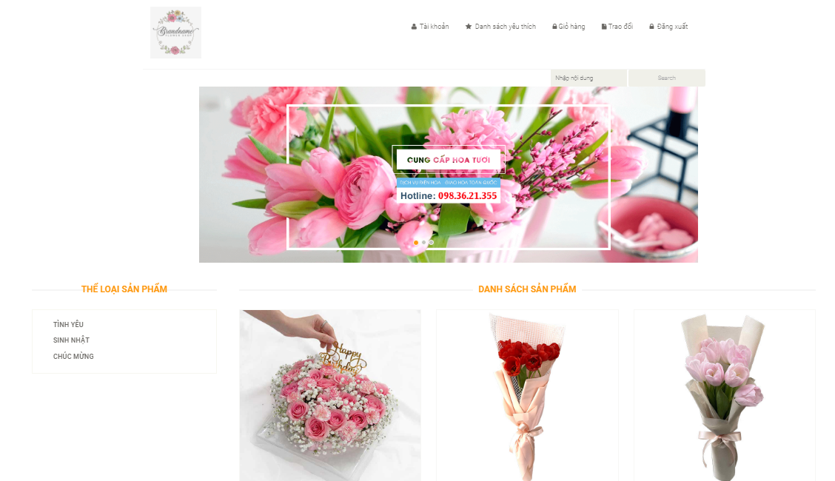

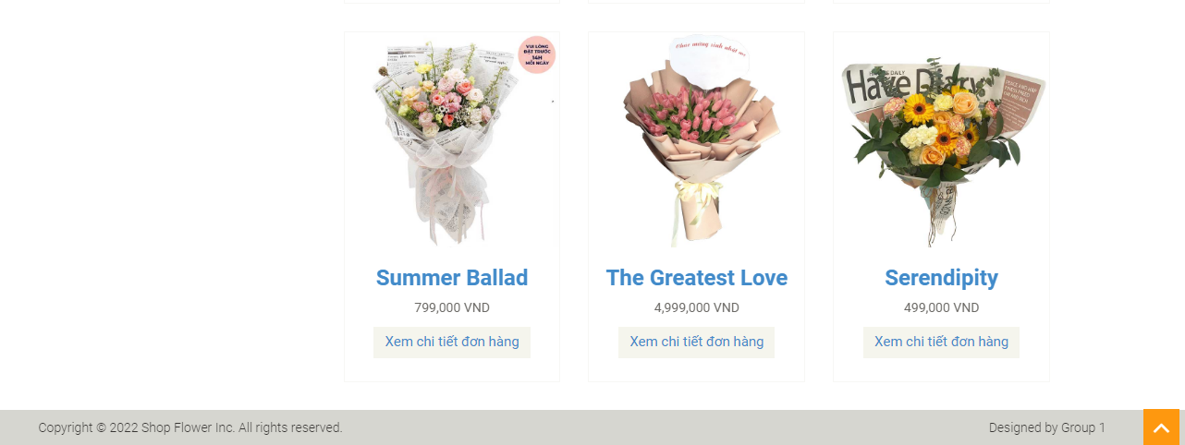

**Register Pages**

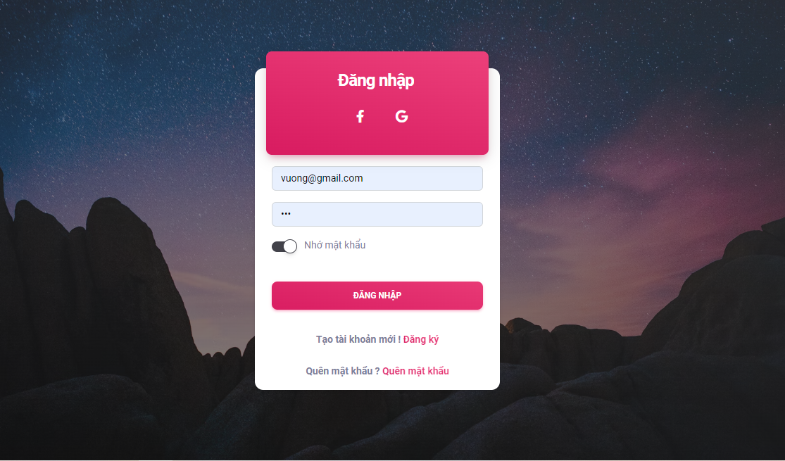

**Admin Pages**

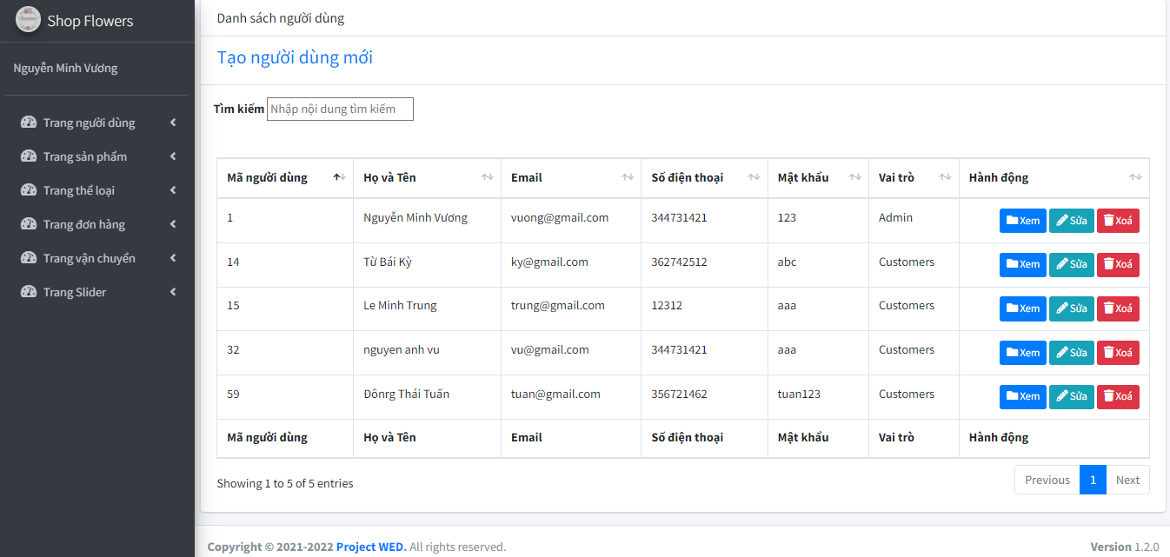

**Product Details**

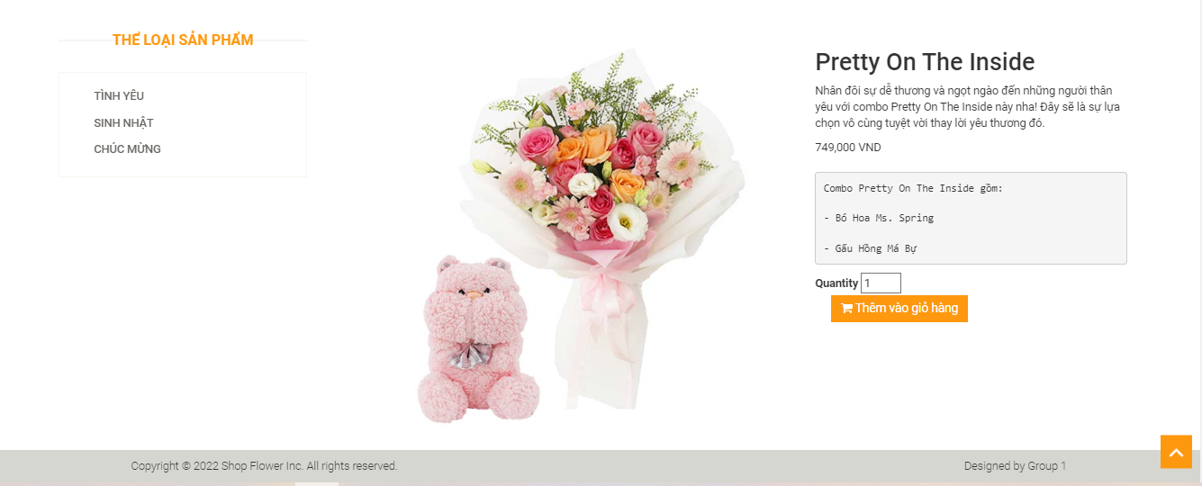

**Contact**

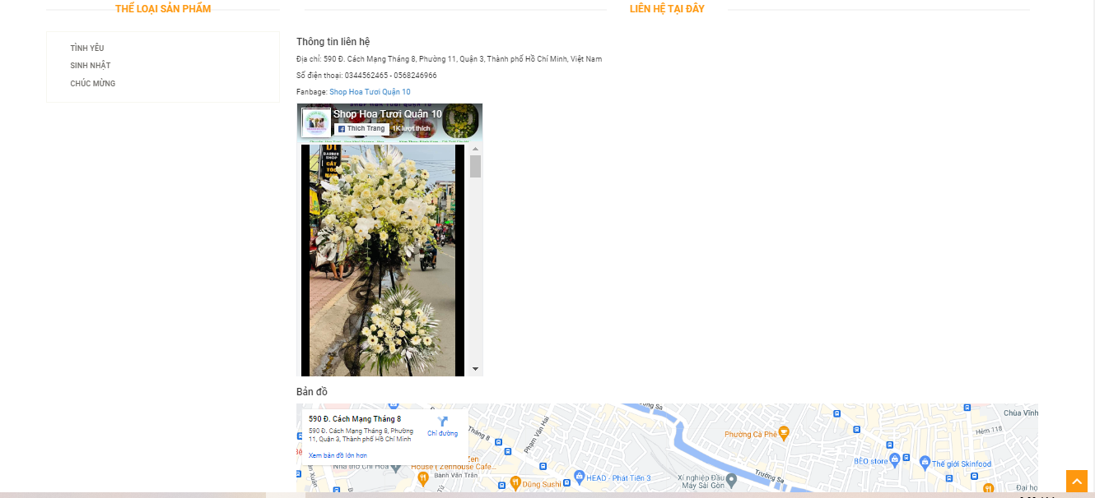

**Cart**

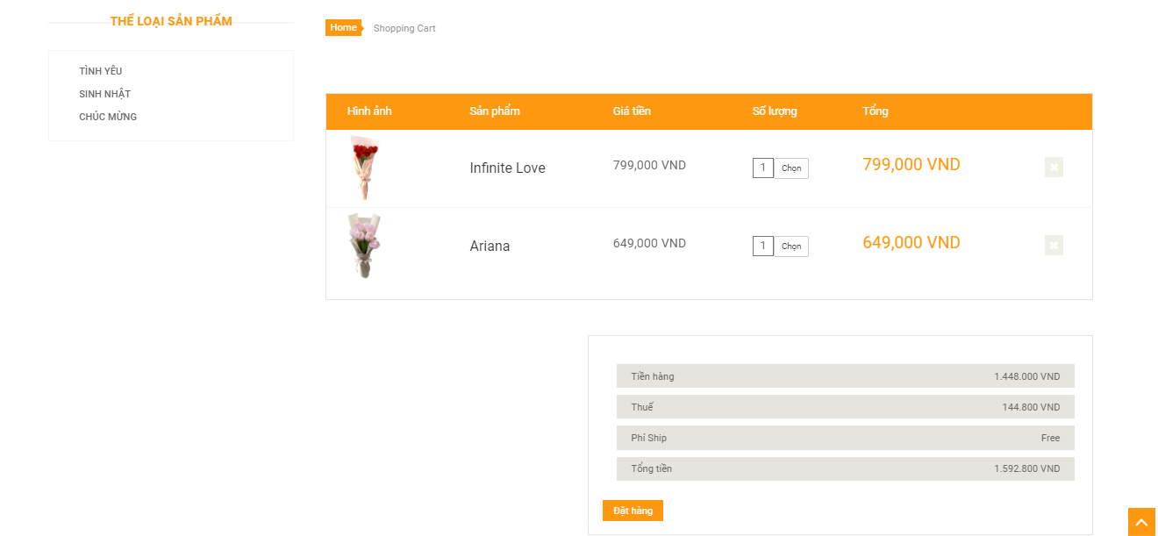

**Check out**

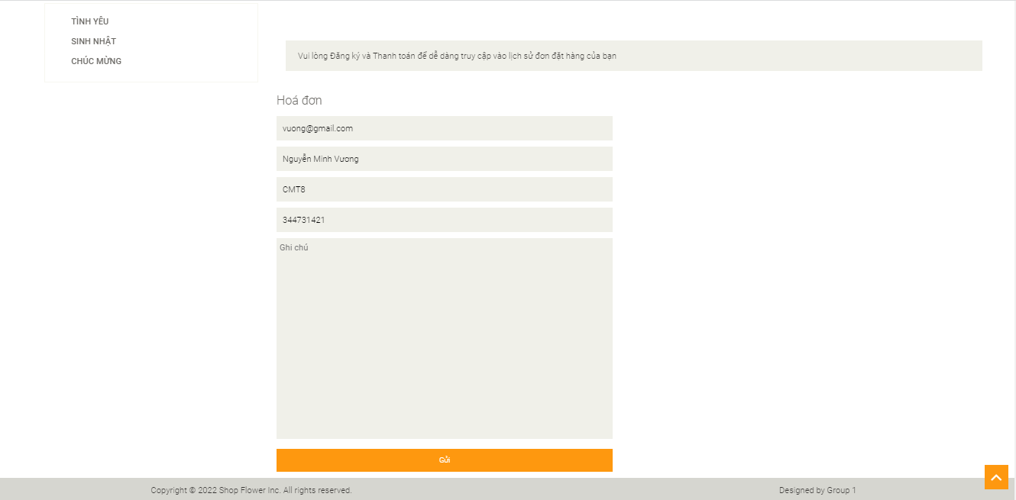

4.TASK SHEET REWIEW 3

| **Project: The Flower Shop** | | **Date of preparation of activity plan:** | | | |
| --- | --- | --- | --- | --- | --- |
| **#** | **Task** | **Start date** | **Days** | **Tteam member name** | **Status** |
| 1 | Database Desing | 15-July-22 | 30 | Vương | completed |
| 2 | Front-End Layout | 15-July-22 | 30 | Vương | completed |
| 3 | Back-End Layout | 15-July-22 | 30 | Vương | completed |
| 4 | CRUD – order, order-item, product, user, admin, category | 15-July-22 | 30 | Vương | completed |
| 5 | CRUD – province, district, ward | 15-July-22 | 30 | Vương | completed |
| 6 | Home page | 15-July-22 | 30 | Vương | completed |
| 7 | Products | 15-July-22 | 30 | Vương | completed |
| 8 | Product detail page | 15-July-22 | 30 | Vương | completed |
| 9 | Login/Register | 15-July-22 | 30 | Vương | completed |
| 10 | Cart | 15-July-22 | 30 | Vương | completed |
| 11 | Checkout | 15-July-22 | 30 | Vương | completed |
| 12 | User Account | 15-July-22 | 30 | Vương | completed |
| 13 | Show-Cart | 15-July-22 | 30 | Vương | completed |
| Date: 07-August-22 | | | | | |
| Signature of instructor | | Signature of Team Leader | | | |
|  | |  | | | |
| Ms. LÊ MỘNG THUÝ | | Nguyễn Minh Vương | | | |